Chapter 18, Problem 11.

Find the Fourier transform of the “sine-wave pulse” shown in Fig. 18.36.

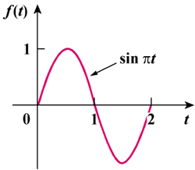

Figure 18.36
For Prob. 18.11.

